New Python Users

GISROM (GR) uses the python interpreter to execute the application, so this must be installed on the system. To install python, visit <https://www.python.org/> and follow the instructions. The minimum version of python is 3.10.

GR relies on several third-party packages, these include:

* Numpy - <https://numpy.org/>

After python is installed, these packages will need to be installed. The easiest way is through pip, but the instructions can be found on each package’s website.

Getting Started

After the python and the packages are installed, navigate to the GitHub repository at <https://github.com/norman-tom/qgis2rorb> to download the code.

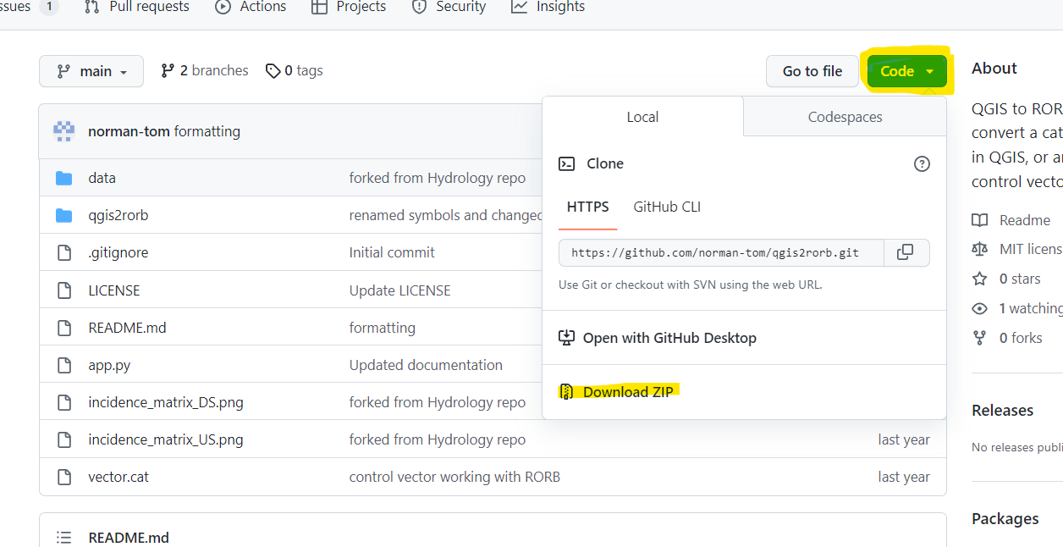

The zip file contains all the necessary parts to execute the program. There is an example project within the *./data* directory that shows how to set up the shapefiles in GIS. These example shapefiles also contained the necessary GIS attributes which convert the catchment to a RORB vector. It is recommended that these shape files are used as a template for your catchment.

Given how lightweight the package is, it is recommended that you move the downloaded folder into your project folder. This allows for modification of the code, to suit the individual needs of the project.

Please note GR is in the early development phase and only supports limited RORB functionality. However, it can be used to generate a base vector and then expanded on with additional functionality.

Setting Up A Catchment

GR uses four shape files to provide the necessary information to build the RORB vector. These include:

**Reaches:**

Reaches are the river connection between basins and confluences. These are a line geometry type.

Attributes:

'id' - The name of the reach [string]  
's' - The slope of the reach [double]. Is ignored for natural reaches.  
't' - Type of reach. Refer to RORB Manual Table 2-2. Only type 1 channels are implemented so far. [integer].

Note: reach length is derived from the shapefile geometry.

**Centroids**

Centroids are the centre of the basin, These are not necessarily the centroid however and can be moved to match the reach. However, centroid to basin matching is done through the nearest neighbour, so in rare circumstances, if a centroid is moved too far away from the basin’s true centroid, it may match with another basin, or not match at all. Centroids are a point geometry type.

Attributes:

'id' The name of the basin [string]  
'fi' The fraction impervious (this is NOT percentage) [decimal]

**Basins**

Basins are only necessary to provide the centroid with an area. This was done to avoid having to transcribe area information into the Centroid shapefile as an attribute. Basin shapefiles do not need any attributes. Basins are a polygon geometry type.

Attributes:

None

**Confluences**

These are the location where reaches meet, which isn't a centroid (no basin information associated). In the future, these will represent other features like storage.

Attributes:

'id' The name of the confluence [string]  
'out' Flag whether this confluence is the out [integer]

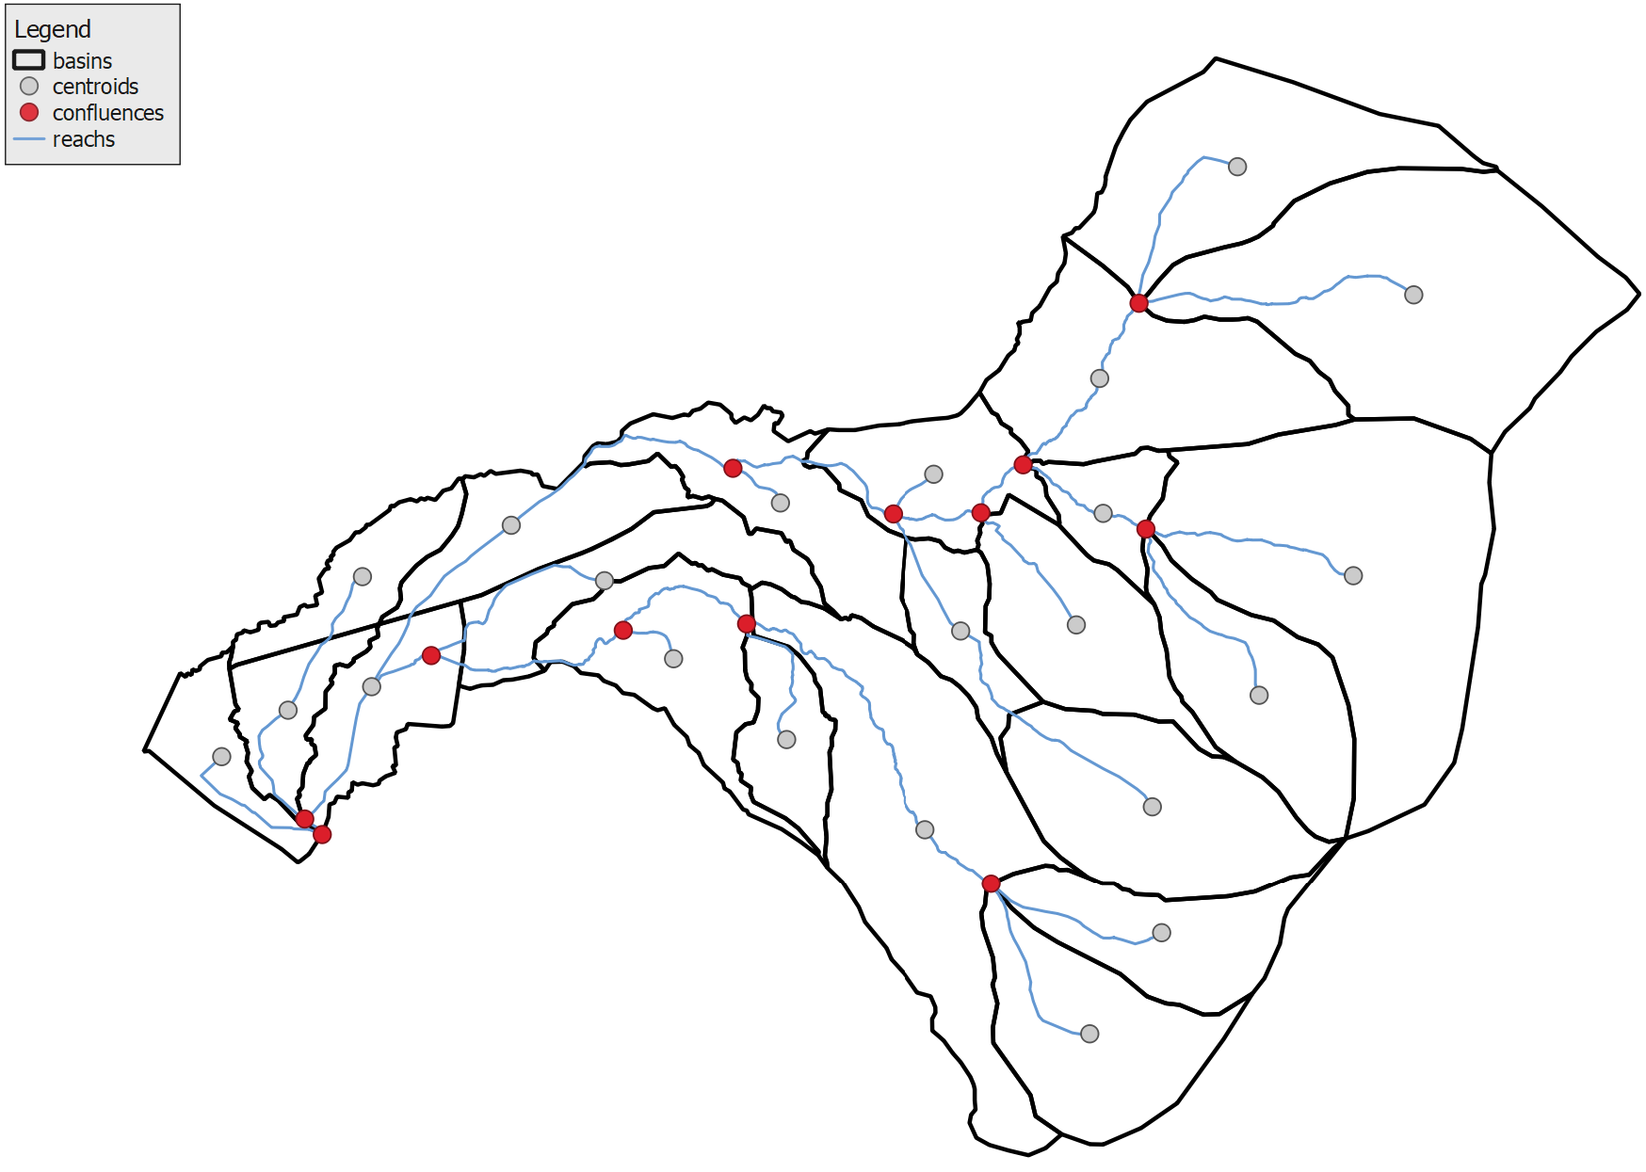

Out location

1. Basins are built in the preferred manner. There are various ways to produce the sub-catchments boundaries, please refer to your typical workflow to do so. These are nothing more than polygons.
2. Centroids are created from the basins, either using the in-built centroid tool in QGIS or estimating the location. Centroids represent a sub-area in the RORB Model. These don’t have the be at the centroid, these can be moved to suit the reaches.
3. Confluences are manually located at junctions of reaches, these represent junction nodes in the RORB model.
4. Reach is the thalweg of the flow paths through the catchment. These are disjointed at each confluence and centroid, that is they must start at an upstream confluence or centroid and end at the immediately downstream confluence or centroid.
5. Out location, the outlet of the catchment must be explicitly nominated by setting the GIS attribute as 1. All other confluence should of their out set at 0.

Saving the Data

Once happy with the catchment, the shape files should be exported to the *./data* directory and named accordingly. A snippet of the codes shows what the builder will search for, if named differently or located in a different directory, the builder will need to be updated in the code with the new names and/or director.

    builder = GR.Builder(os.path.join(dirname, 'data', 'reaches.shp'),

                          os.path.join(dirname, 'data', 'basins.shp'),

                          os.path.join(dirname, 'data', 'centroids.shp'),

                          os.path.join(dirname, 'data', 'confluences.shp'))

For example for the reaches, export from GIS to ./data/reaches.shp

Selecting Between RORB and WBNM

GR can also build basic WBNM models. To select the hydrological model to use, open up the “app.py” in a text editor and change the following line of code. The default is set to RORB. Setting up the catchment diagrams is similar expect WBNM requires that only one subarea is connected to the outfall.

    model = GR.RORB() # Select your hydrology model, either GR.RORB() or GR.WBNM()

Running the App

The easiest way to run a python application is to associate .py files with the python interpreter. Then it is a simple as double-clicking in the “app.py” file.

Alternatively, open up a terminal and navigate to the location of the “app.py” file. Run the command “python app.py”. The RORB vector will be saved to the same directory as the “app.py” with the name “vector.cat”

Validating the vector

As this project is in such early stages and comes without warranty or liability under the MIT license, it is important that the control vector is checked. There are three ways to ensure it was built correctly.

The incidence matrix is plotted for both the downstream and upstream connections. These can be large depending on the catchment but it shows which centroid/confluence is connected by which reach. Looking to the left we see the confluence/centroid IDs, locating number 7, we see that it is connected with reach 7.E (on the bottom) and its downstream centroid is node 20 which is E. Node number is given in the []. A -1 indicated no connection. 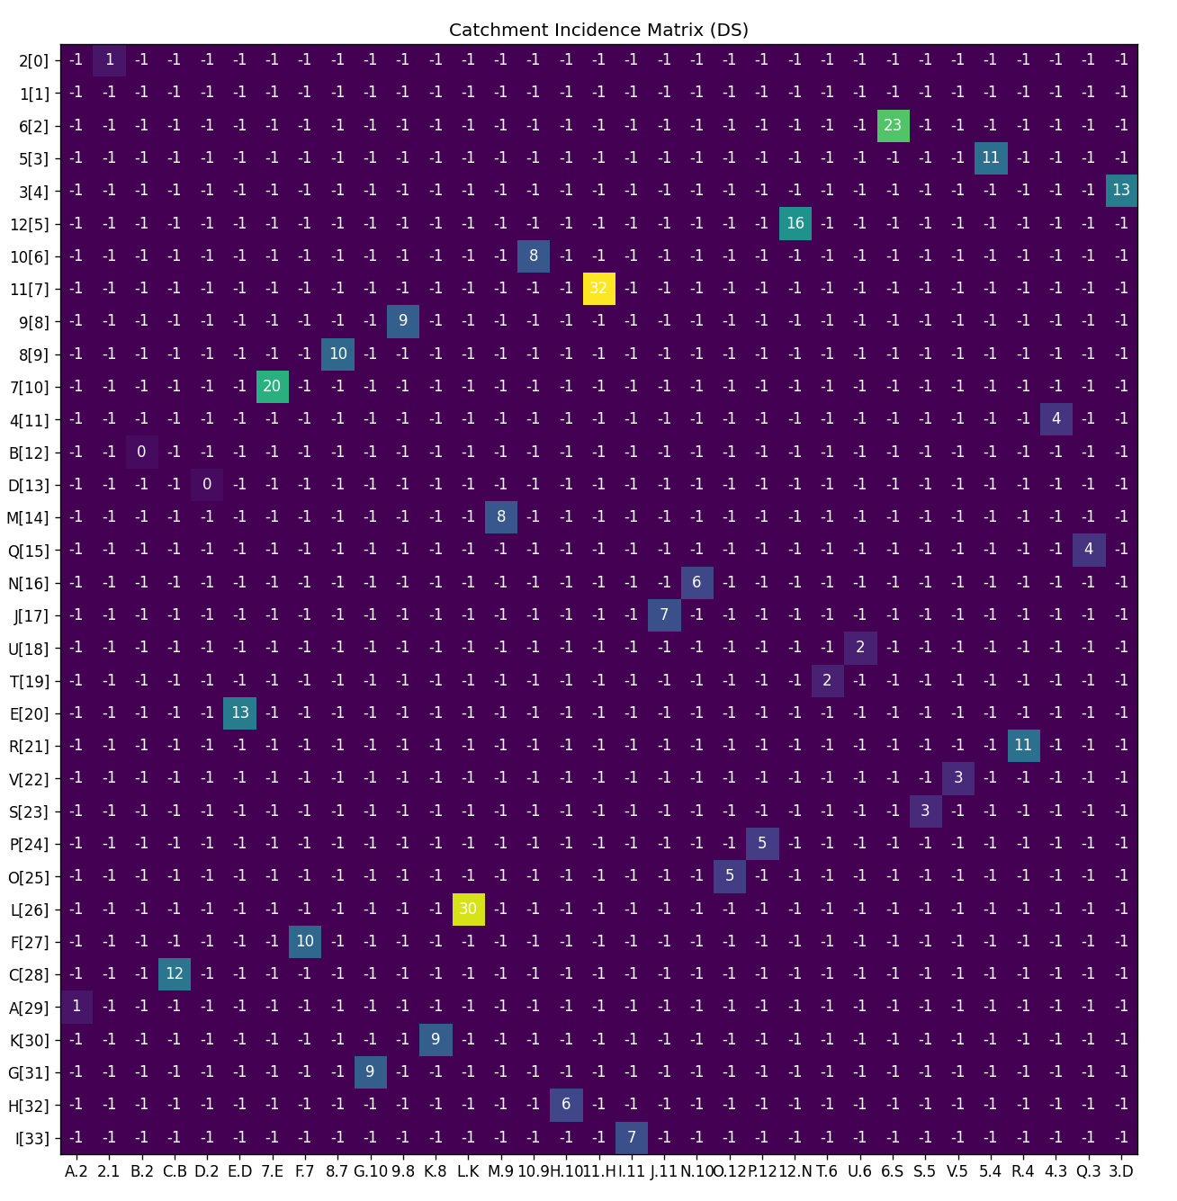

A plot of the geometry is also given, this shows how the reaches and confluences/centroids are arranged and connected. This exactly represents the GIS information passed to the application. Chart, line chart

After validation, the plotting can be turned off by modifying the code in the “app.py”. Open up a text editor and change “plot” from True to False.

    plot = True # Set True if you want the catchment to be plotted

The last check is using the RORB graphical editor and importing the built catchment vector. Simply load the vector with RORBwin and then go to the GE (graphical editor). While not spatially correct, the connection should represent the intention.

